Title: Adaptive force control of advanced hand prostheses using surface electromyography: initial results on a patient (case report)
Authors:
Claudio CASTELLINI, Ph.D, University of Genova, Italy
Emanuele GRUPPIONI, M.Eng., INAIL Centro Protesi, Vigorso di Budrio, Italy
Angelo DAVALLI, M.Eng., INAIL Centro Protesi, Vigorso di Budrio, Italy
Giulio SANDINI, M.Sc., Italian Institute of Technology, Genova, Italy
Short title:
Adaptive EMG-controlled prostheses
Corresponding author:
Claudio CASTELLINI
LIRA-Lab, University of Genova
viale F. Causa, 13 – 16145 Genova, Italy
phone +39 338 413 4970
fax +39 010 353 2948
email claudio.castellini@unige.it
Abstract
Objective. We aim at showing that adaptive methods for force control of polyarticulate hand prostheses, namely machine learning applied to surface electromyography (EMG), can be successfully employed by amputees, greatly improving the s.o.a. Subjects/Patients. A 64 y.o. male, left-side first proximal trans-radial amputee joined the experiment. He underwent surgery in 1963 and has been using myoelectric prostheses since then. His stump is about 8cm long. Methods. A Support Vector Machine (SVM) was trained on the patient’s EMG patterns, recorded while the subject was asked to perform imaginary grasp actions. A force sensor was used in three different ways, to train the machine. Results. The SVM can distinguish five different grasp types up to a precision of about 96% and approximate the amount of force required by the patient, generating a signal up to 88% correlated to the patient’s will. Conclusion. Our technique, we argue, can be successfully employed for force control of a polyarticulate prosthesis such as, e.g., Touch Bionics’s i-LIMB, at least in the case of this subject, in a natural, relatively cheap, non-invasive way. It is actually surprising that so much diverse and delicate muscular activity is left in the patient’s stump, 45 years after the operation, which lets us hope for the best as far as general applicability of our technique is concerned.
Journal: Journal of Rehabilitation Medicine
Principal author: Claudio CASTELLINI, LIRA-Lab, University of Genova, viale F. Causa, 13, 16145 Genova, Italy, email claudio.castellini@unige.it
Keywords: Artificial Limbs [E07.695.050], Artificial Intelligence [L01.224.065], Robotics [L01.224.065.630], Man-Machine Systems [J01.293.556.441], Amputees [M01.150.100]
Introduction
Control, and in particular force control, is nowadays probably the main concern in the clinical application of upper-limb active prostheses. Current solutions are based on electromyography (EMG (1)) and electronic switches, and no force control is really provided. In the former case, which is also the most common, EMG sensors detect the electrical signals produced by residual muscles in the stump; an electronic control unit is then responsible for processing the signals, and accordingly activating the motors. This way the patient is able to control some specific movements, e.g., trans-radial amputees typically can open and close an electro-mechanical claw by using the flexor-extensor muscles of the wrist (2).
These techniques have at least two main drawbacks: (a) long training curves for the patients due to the unnatural control solution; (b) incomplete restoration of hand functionality, due to the limited number of degrees-of-freedom. But recently, bionics has substantially improved the s.o.a. of commercially available prosthetic hands, an example being Touch Bionics’s i-LIMBTM hand (3). This prosthesis is able to perform several distinct grasps; but even in this case, the control strategy is rough: the opening and closing movements are performed by all the fingers simultaneously, based upon the contraction of flexor-extensor muscles of the wrist; and most of the adaptability is left to the compliance of the hand itself.
It arises, then, the necessity of a control method which must be (a) more natural from the patient’s point of view, and (b) finer, i.e., it must allow several grasp types to be independently controlled, and force to be controlled, so that the patient is able, e.g., to hold an egg without breaking it, and holding a hammer without letting it slip.
In the past, e.g. (4,5), machine learning methods, that is, highly adaptive statistical tools, have been successfully applied to EMG to classify isotonic, isometric postures of the hand; more recently (6,7) it has been shown that such a particular technique called Support Vector Machines (SVM) obtains good results in classifying grasp types and approximating the force required in each grasp. This latter experiment, surprisingly, had never been done before. Anyway, the experiments therein were all done on healthy subjects; the main question remains unanswered then, of checking whether an amputee could actually use the system with similar proficiency.
In this paper we investigate this possibility, by applying an SVM to the EMG signal generated by a trans-radial proximal amputee. We show that the patient is potentially able to control five different grasp types up to a precision of 96%, and the required force up to a correlation of 88%, paving the way for the next generation of EMG-controlled hand prostheses, which will be adaptive and naturally force-controlled.
Methods
The patient is a 64 y.o. male, Italian, left-side first proximal trans-radial amputee (see Figure 1(a)). He underwent surgery in 1963 and has been using myoelectric prostheses since then. His stump is about 8cm long (Figure 1(b)). To record the EMG signal, five OttoBock MyoBockTM electrodes were used, evenly placed around his stump (Figure 1(c)). We also used a linear force sensor to associate EMG patterns to the required force. A standard digital acquisition card and an entry-level laptop were used to acquire the signals at a sampling rate of 100Hz.
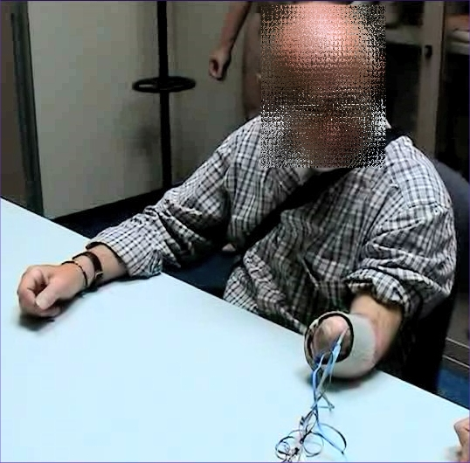 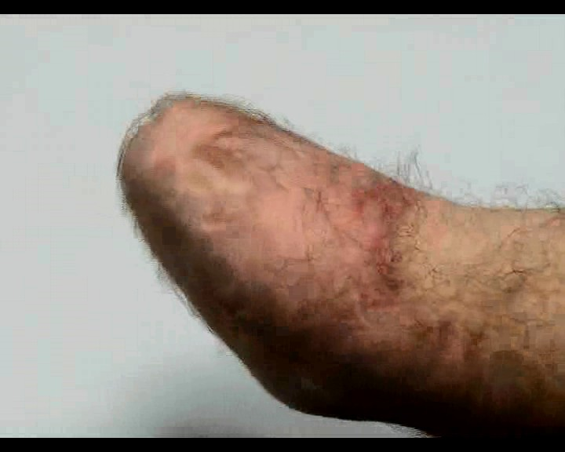 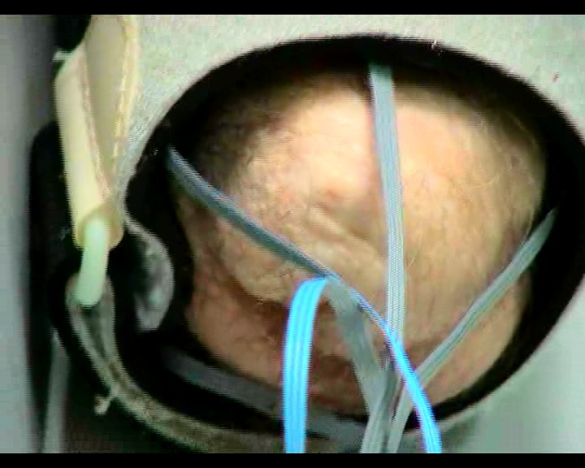
Figure 1: (a) (b) (c)
The patient was asked to “perform” 5 different grasps/postures (no action, pointing index, pinch grip, tripodal grip, power grasp) with free force and speed, while we would record the EMG and force sensor activity. Three ways of training the system (modalities) were employed:
1. teacher imitation. A healthy subject (teacher) would place his left arm besides the patient’s stump and ask him to “imitate” the grips. The subject was asked to imagine gripping with his maximum strength.
2. bilateral action. The patient was asked to grip the force sensor with his healthy hand while “doing” the same things with his stump.
3. mirror-box. Same as modality 2, but a mirror was placed between the patient’s arms, in order to increase the visual feedback (8).
Figure 2 shows the patient in action during the three modalities.
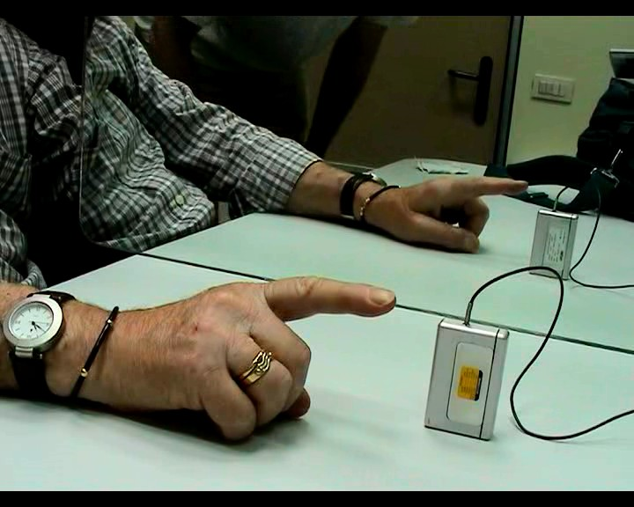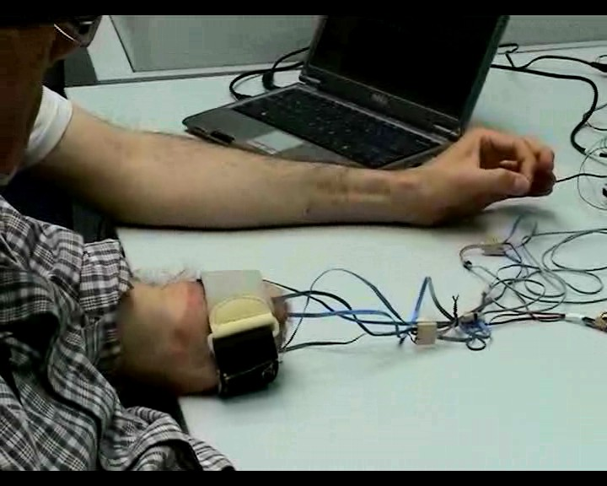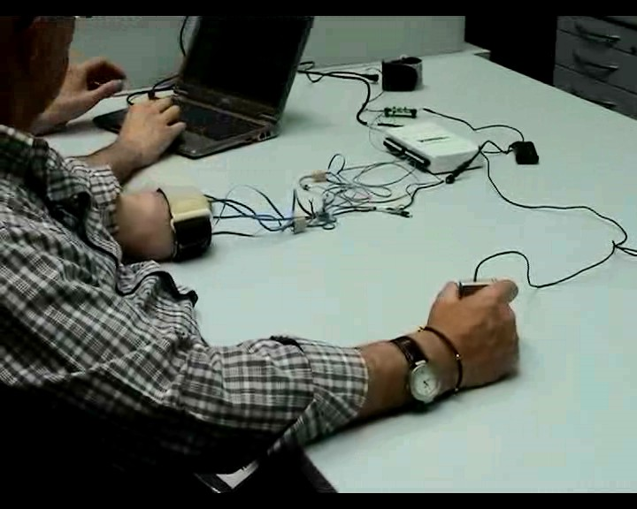
Teacher imitation Bilateral action Mirror-box
Figure 2
Spectral analysis of the EMG signals reveals that, as is well-known (9), the relevant bandwidth lies below 10-15Hz (the OttoBock electrodes already perform an RMS operation); so the signals have been subsampled at 25Hz from the original 100Hz. Categories were assigned to samples according to the type of grasp the subject was asked to perform; the force value was, in the case of modality #1, the maximum possible, and the sensor was pressed by the teacher himself. Samples with low force values were removed from the data set.
To start with, Principal Component Analysis reveals that the 5 signals can be reduced to 2 without losing more than 10-15% variance.
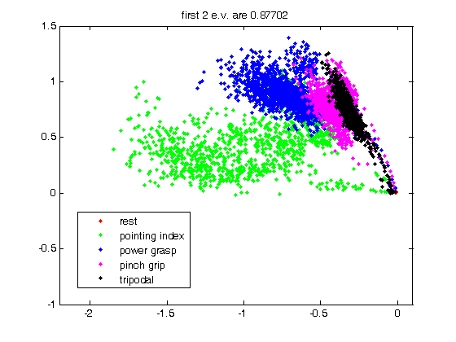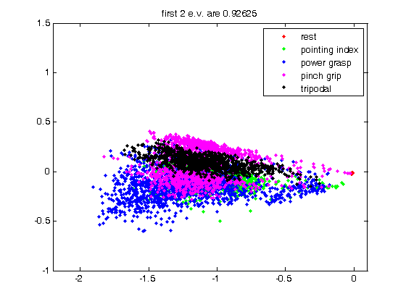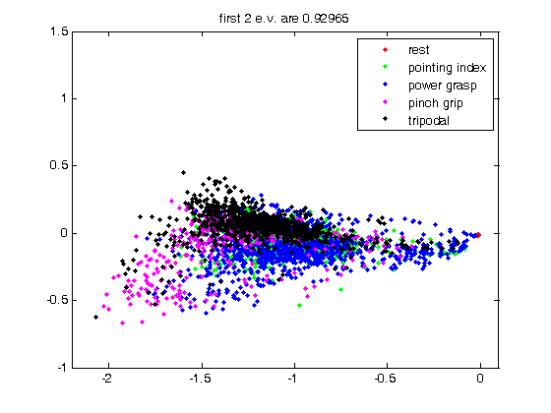
Figure 3
Visual inspection of the samples, coloured according to the grasp type required (see Figure 3), further reveals that the grasps produce remarkably well-identifiable samples, especially in the case of teacher imitation, and that teacher imitation is, from this point of view, by far better than the other two modalities.
Subsequently, a Support Vector Machine (SVM , (10)) was trained on the acquired data. SVMs are a statistical learning method able to reconstruct, with a provably low error, a function associating values in an input space to values in an output space. In our case, the input space is given by the EMG values, and the output space is two-fold: the machine is asked to detect both (a) which kind of grasp the patient is applying (classification); and (b) how much force the patient is trying to apply (regression).
Results
In the following, as a measure of performance, we present the classification accuracy ratio for the classification problem, and the correlation between the truly applied force and the force detected by the SVM, for the regression problem. Table 1 shows the results for the three modalities, both using the signal “as-is”, and applyng a second-order low-pass filter with cutoff frequency at 5Hz on the EMG signal.
 | imitation | bilateral | mirror
as-is | 93.1% / 0.86 | 79.2% / 0.80 | 75.8% / 0.78
filtered | 96.0% / 0.88 | 88.1% / 0.86 | 85.7% / 0.85
Table 1
As one can see, results match the graphical intuition of the previous Section. The SVM is able to correctly classify the types of grasps required by the patient, with a precision of up to 96%; and to reconstruct the required force up to a precision of 0.88 correlation. The filtered signal gives uniformly better results – this is due to high-frequency noise components that are removed via filtering. A surprising fact is that the results are uniformly better using modality 1 than 2, and 2 than 3 – this seems to hint at a better control of the missing limb by the patient in presence of a teacher, that is, when he is learning by imitation rather than trying to do bilateral action. The use of the mirror seems to make things slightly worse, which we did not really expect.
Discussion
One could see this work as a follow-up to (6,7), aimed at giving an initial answer to the fundamental question: can an amputee naturally control a polyarticulate hand prosthesis using surface EMG? In the case of our patient, the answer is definitely yes. The patient is able to drive the system (and therefore, potentially, the prosthesis) to the right grasp type and with the correct amount of force. Interstingly, this latter point is, as far as we know, totally new, notwithstanding the highly desirable requirement to modulate the force in a grasp.
Notice that the relationship between the RMS of the EMG signal and the contraction force of a muscle is well-known in literature; what is new here is (a) the possibility of understanding the force independently of the grasp type and using the forearm, where 19 muscles “talk” at the same time, and (b) the possibility of training the machine upon the patient’s patterns, paving the way for adaptive prosthetics.
Since our experiment has involved one patient only so far, we are not in the position of making any more general statement about the applicability of the technique; but if we take into account that the patient was amputated a long time ago, and that the results here presented are excellent, we can hope for the best. (We are actually in the process of applying the same system to more patients.) In fact, our previous results in (6) actually show that such an accuracy as that obtained here is perfectly suited to force-control a non-prosthetic mechanical hand.
If confirmed on a broader range of patients, our results would open up the exciting scenario of a patient being able to control in a totally natural way a polyarticulated hand prosthesis, such as, e.g., Touch Bionics’s i-LIMBTM; and this could be achieved via a technique which is absolutely non-invasive, avoiding surgery, post-operation sterility issues and psychological acceptance, and relatively cheap, employing five commercially available EMG electrodes.
References
1. C. J. De Luca, The use of surface electromyography in biomechanics, Journal of Applied Biomechanics, 13:135-163, 1997.
2. Otto Bock, the SensorHand® SPEED prosthetic hand. See http://www.ottobockus.com .
3. Touch Bionics, the i-LIMB® prosthetic hand. See http://www.touchbionics.com .
4. S. Bitzer and P. van der Smagt, Learning EMG control of a robotic hand: Towards active prostheses, in Proceedings of ICRA, International Conference on Robotics and Automation, Orlando, Florida, USA, may 2006, pp. 2819–2823.
5. S. Ferguson and G. R. Dunlop, Grasp recognition from myoelectric signals, in Proceedings of the Australasian Conference on Robotics and Automation, Auckland, New Zealand, 2002.
6. C. Castellini and P. van der Smagt, Surface EMG in Advanced Hand Prosthetics, to appear in Biological Cybernetics, 2008.
7. C. Castellini, A. E. Fiorilla and G. Sandini, Multi-Subject/DLA Analysis of Surface EMG Control of Mechanical Hands, poster at the I National Bioengineerings Group meeting, Pisa, Italy, 2008, and manuscript in preparation for Biological Cybernetics.
8. V. S. Ramachandran and D. Rogers-Ramachandran. Synaesthesia in phantom limbs induced with mirrors. Proceedings of the Royal Society B: Biological Sciences, 263(1369), 377-386, 1996.
9. M. Zecca, S. Micera, M. C. Carrozza and P. Dario, Control of Multifunctional Prosthetic Hands by Processing the Electromyographic Signal, Critical Reviews in Biomedical Engineering, 30(4–6):459–485, 2002.
10. B. E. Boser, I. M. Guyon, and V. N. Vapnik, A training algorithm for optimal margin classifiers, in Proceedings of the 5th Annual ACM COLT Workshop, ACM press, 1992, pp. 144–152.

